SPRINT 4

|  |  |
| --- | --- |
| Date | 14 November 2022 |
| Team ID | PNT2022TMID15007 |
| Project Name | Hazardous Area Monitoring for Industrial Plant powered by IoT |

# WOKWI CODE:

#include<WiFi.h>//libraryforwifi #include<PubSubClient.h>//libraryforMQtt #include"DHT.h"//Libraryfordht11

#defineDHTPIN15 // what pin we're connected to #defineDHTTYPEDHT22 // define type of sensor DHT 11 #define LED2

DHTdht(DHTPIN,DHTTYPE);//creatingtheinstancebypassingpinandtyprofdht connected

voidcallback(char*subscribetopic,byte*payload,unsignedintpayloadLength);

//-------credentialsofIBMAccounts------

#defineORG"iagqzu"//IBMORGANITIONID

#defineDEVICE_TYPE"Deepak"//DevicetypementionedinibmwatsonIOTPlatform #defineDEVICE_ID"123"//DeviceIDmentionedinibmwatsonIOTPlatform #defineTOKEN"12345678" //Token

String data3; float h, t;

//--------Customisetheabovevalues--------

charserver[]=ORG".messaging.internetofthings.ibmcloud.com";//ServerName charpublishTopic[]="iot-2/evt/Data/fmt/json";//topicnameandtypeofevent performandformatinwhichdatatobesend

charsubscribetopic[]="iot-2/cmd/command/fmt/String";//cmdREPRESENTcommandtype ANDCOMMANDISTESTOFFORMATSTRING

charauthMethod[]="use-token-auth";//authenticationmethod chartoken[]=TOKEN;

charclientId[]="d:"ORG":"DEVICE_TYPE":"DEVICE_ID;//clientid

// -

WiFiClientwifiClient;//creatingtheinstanceforwificlient

PubSubClientclient(server,1883,callback,wifiClient);//callingthepredefined clientidbypassingparameterlikeserverid,portandwificredential

voidsetup()//configureingtheESP32

{

**Serial**.begin(115200);

dht.begin(); pinMode(LED,OUTPUT); delay(10); **Serial**.println(); wificonnect(); mqttconnect();

}

voidloop()//RecursiveFunction

{

h = dht.readHumidity();

t = dht.readTemperature(); **Serial**.print("temp:"); **Serial**.println(t); **Serial**.print("Humid:"); **Serial**.println(h);

PublishData(t, h); delay(1000);

if(!client.loop()){ mqttconnect();

}

}

/*.....................................retrieving to

Cloud. */

voidPublishData(floattemp,floathumid){ mqttconnect();//functioncallforconnectingtoibm

/*

creatingtheStringininformJSontoupdatethedatatoibmcloud

*/

Stringpayload="{\"temp\":"; payload+=temp;

payload+=",""\"Humid\":"; payload+=humid;

payload += "}";

**Serial**.print("Sending payload: ");

**Serial**.println(payload);

if(client.publish(publishTopic,(char*)payload.c_str())){

**Serial**.println("Publishok");//ifitsucessfullyuploaddataonthecloudthenit willprintpublishokinSerialmonitororelseitwillprintpublishfailed

} else{

**Serial**.println("Publishfailed");

}

}

voidmqttconnect(){

if (!client.connected()) { **Serial**.print("Reconnectingclientto"); **Serial**.println(server);

while(!!!client.connect(clientId,authMethod,token)){

**Serial**.print("."); delay(500);

}

initManagedDevice();

**Serial**.println();

}

}

voidwificonnect()//functiondefinationforwificonnect

{

**Serial**.println(); **Serial**.print("Connecting to ");

WiFi.begin("Wokwi-GUEST","",6);//passingthewificredentialstoestablishthe connection

while(WiFi.status()!=WL_CONNECTED){ delay(500);

**Serial**.print(".");

}

**Serial**.println(""); **Serial**.println("WiFiconnected"); **Serial**.println("IPaddress:"); **Serial**.println(WiFi.localIP());

}

voidinitManagedDevice(){

if (client.subscribe(subscribetopic)) { **Serial**.println((subscribetopic)); **Serial**.println("subscribetocmdOK");

} else{

**Serial**.println("subscribetocmdFAILED");

}

}

voidcallback(char*subscribetopic,byte*payload,unsignedintpayloadLength)

{

**Serial**.print("callback invoked for topic: ");

**Serial**.println(subscribetopic);

for(inti=0;i<payloadLength;i++){

//Serial.print((char)payload[i]); data3+=(char)payload[i];

}

**Serial**.println("data:"+data3); if(data3=="lighton")

{

**Serial**.println(data3); digitalWrite(LED,HIGH);

}

else

{

**Serial**.println(data3); digitalWrite(LED,LOW);

}

data3="";

}

# WOKWI OUTPUT:

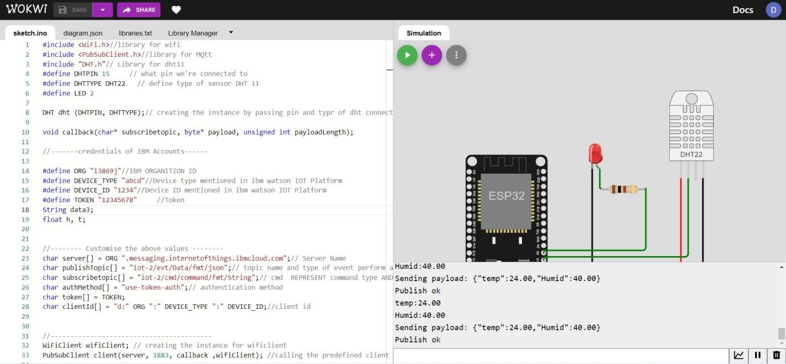

**IBMWATSONPLATFORM** ➔

**DEVICE EVENT LOG:**

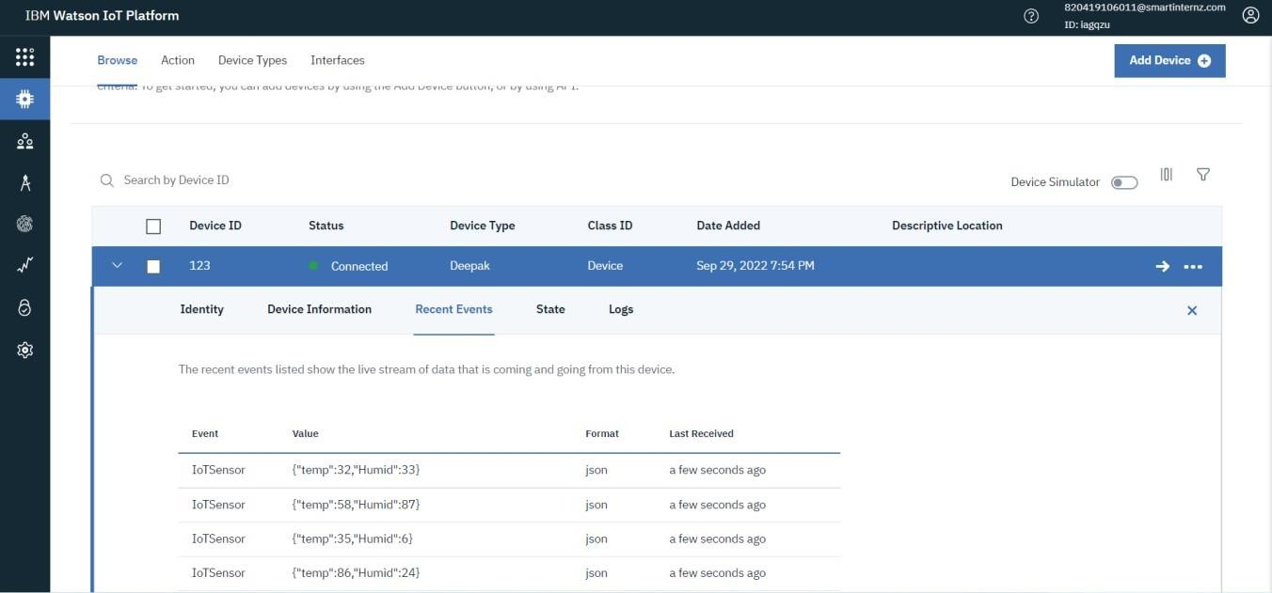

**DEVICE EVENT PAYLOAD:**

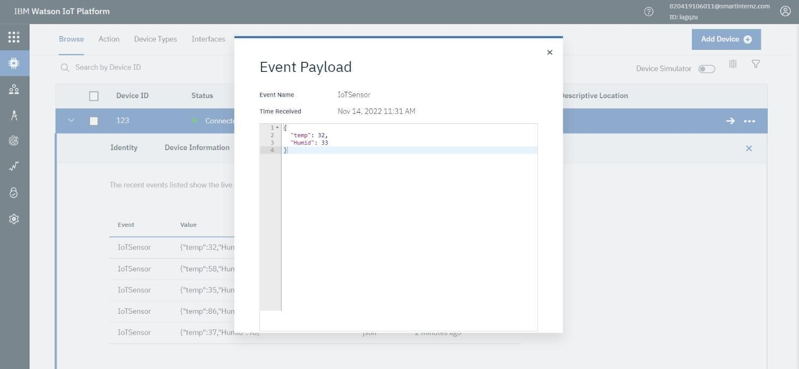

**DEVICE- BOARD:**

